Nandang Duryat - 312310233



Tugas Algoritma & Struktur Data

Tugas – Fungsi

Nandang Duryat – 312310233 (TI.23.C4)

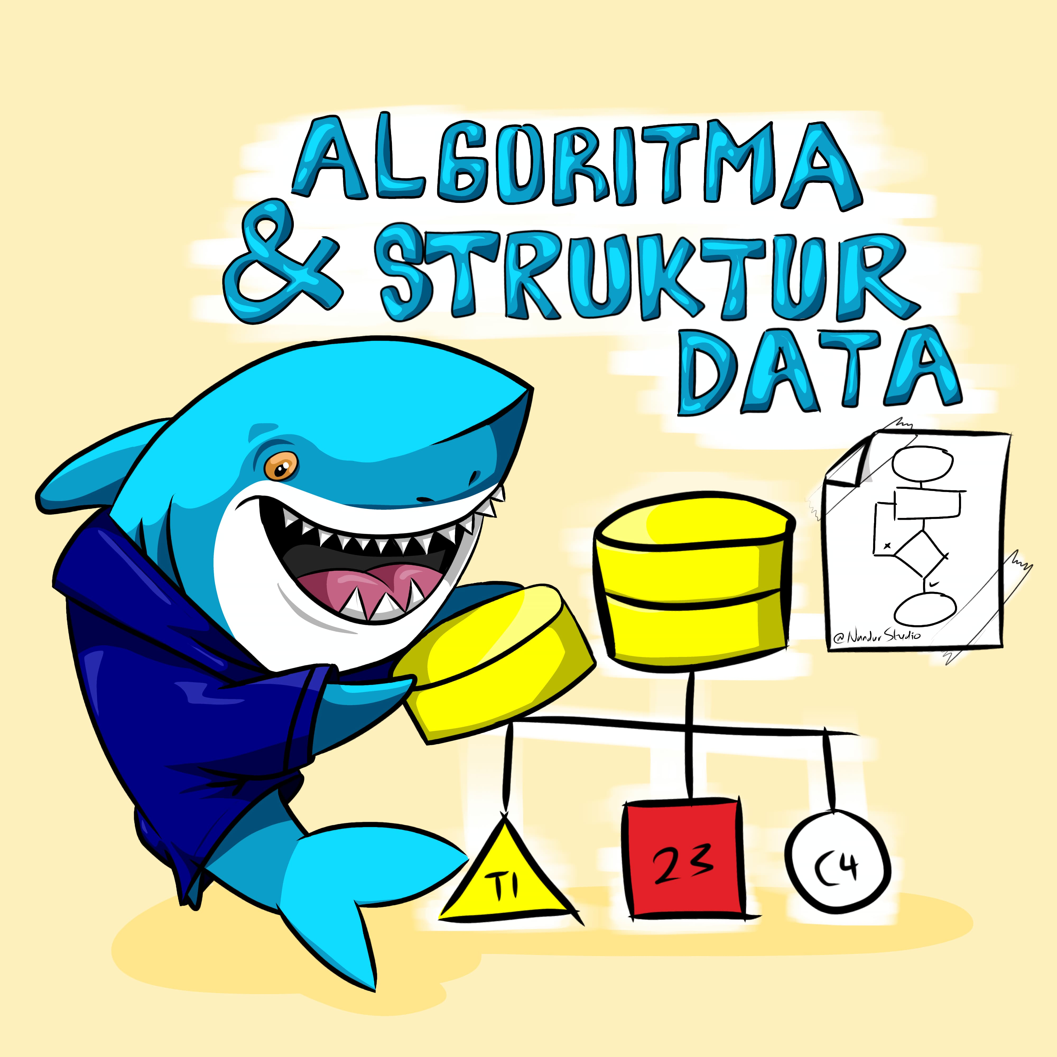

2023

Tugas Algoritma & Struktur Data

Nandang Duryat – 312310233

TI.23.C4

Dosen Muhammad Fatchan, S.Kom., M.Kom., MTCNA.

Sabtu, 18-Nov-23

Pertemuan ke 9

**Tugas – Fungsi**

IDE, Console & Debugger : VSCode

Operating System : Windows 10 pro

**Tugas Fungsi**

Coba jalankan fungsi yang ada di slide materi Pertemuan 9

**Kode Python**

from math import *

def slide(x):

  print("\n")

  print("Slide", x)

  print("#=====================")

#===========================

#slide 2

slide("2")

print("Hello, UPB!") # calls print() function

#===========================

#slide 3

slide("3")

print(ceil(99.23))

print(pow(5,3))

print(factorial(6))

#===========================

#slide 4

# compute factorial of 3

slide("4")

result = 1

for i in range(1,4):

  result *= i

print("Factorial of", 3, "is", result)

# compute factorial of 4

result = 1

for i in range(1,5):

  result *= i

print("Factorial of", 4, "is", result)

#===========================

#slide 6, 7

slide("6, 7")

def my_factorial(n): # function signature

    # function body

    result = 1

    for i in range(1,n+1):

        result *= i

    return result

print(my_factorial(2))

#===========================

#slide 8, 9, 10

slide("8, 9, 10")

def hi(kota):

    print("Hi, " + kota + "!")

hi("Karawang")

#===========================

#slide 11, 12

slide("11, 12")

def hi_fitri():

    name = "Nandur"

    print("Hi, " + name + "!")

hi_fitri()

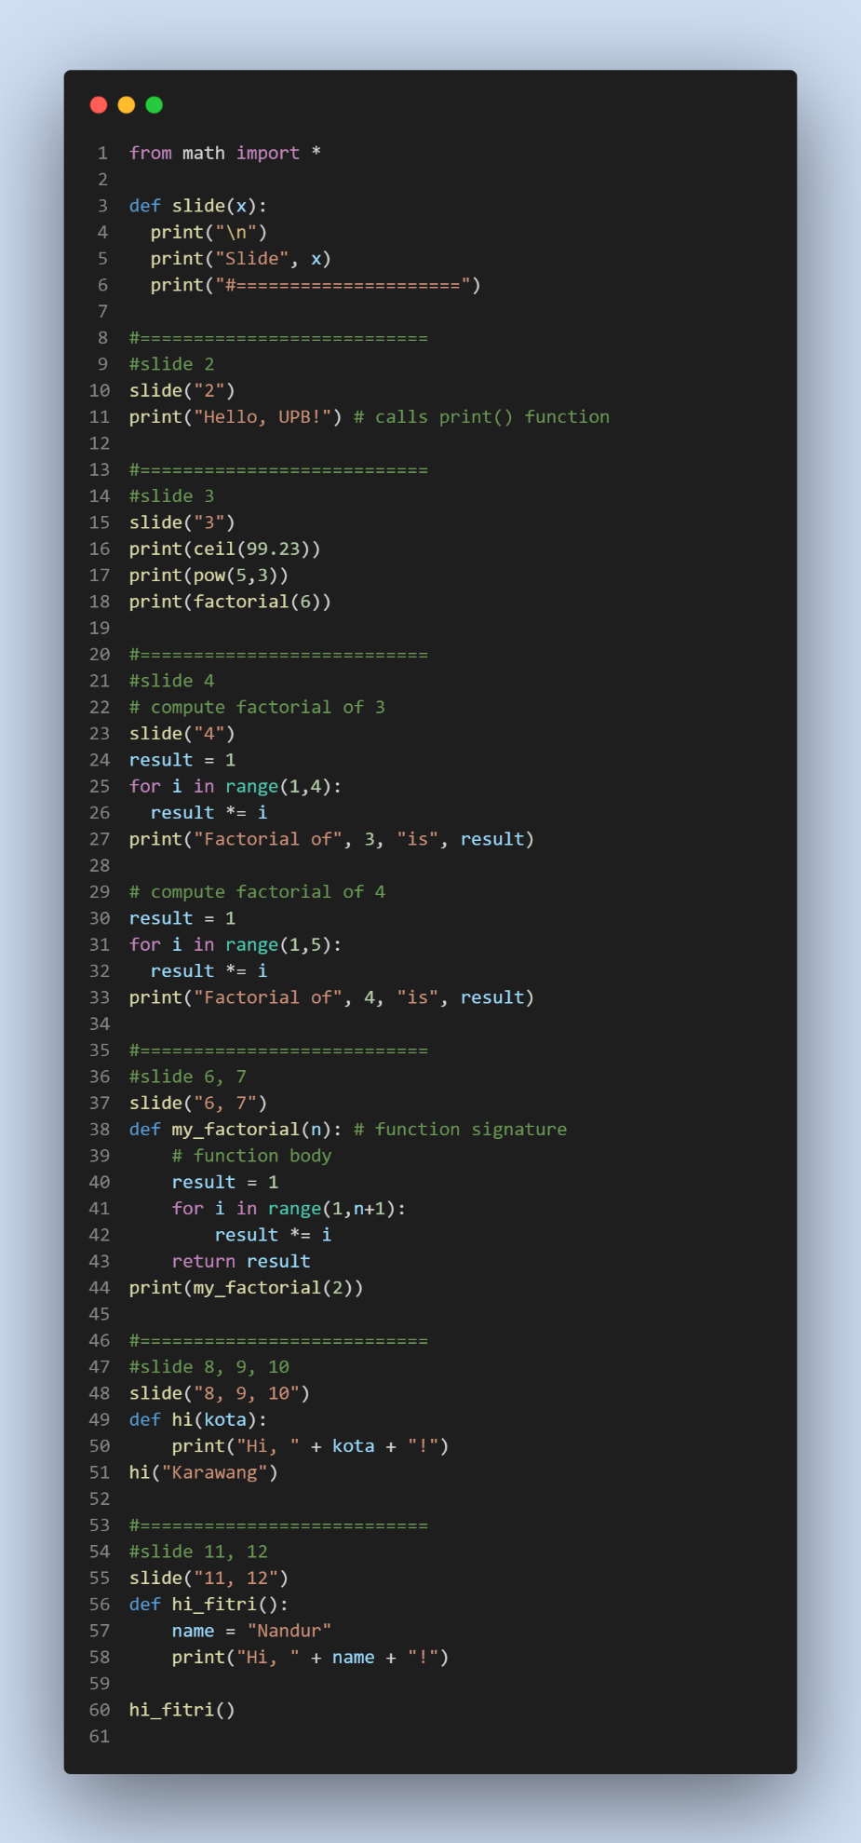**Gambar Syntax**

**Output Console**

